**3 Golden rules of accounting**

It’s no secret that the world of accounting is run by credits and debits. Debits and credits make a book’s world go ‘round.

Before we dive into the golden principles of accounting, you need to brush up on all things debit and credit.

Debits and credits are equal but opposite entries in your accounting books. Credits and debits affect the five core types of accounts:

* **Assets**: Resources owned by a business which have economic value you can convert into cash (e.g., land, equipment, cash, vehicles)
* **Expenses**: Costs that occur during business operations (e.g., wages, supplies)
* **Liabilities**: Amounts owed to another person or business (e.g., [accounts payable](https://www.patriotsoftware.com/blog/accounting/what-are-accounts-payable/))
* **Equity**: Your assets minus your liabilities
* **Income and revenue**: Cash earned from sales

A debit is an entry made on the left side of an account. Debits increase an asset or expense account or decrease equity, liability, or revenue accounts.

A credit is an entry made on the right side of an account. Credits increase equity, liability, and revenue accounts and decrease asset and expense accounts.

You must record credits and debits for each transaction.

The golden rules of accounting also revolve around debits and credits. Take a look at the three main rules of accounting:

1. Debit the receiver and credit the giver
2. Debit what comes in and credit what goes out
3. Debit expenses and losses, credit income and gains

|  |  |  |
| --- | --- | --- |
| Type of Account | Dr | Cr |
| Personal A/C  (Debtors and Creditors)* | Receiver | Giver |
| Real A/C  (All types of Tangible or Intangible Assets ) | What Comes in | What Goes Out |
| Nominal A/C  (Income and Expenses) | All Expenses / Losses | All Income / gains |

* a **creditor** is someone who lends money while a **debtor** is someone who owes money to a **creditor**.

* a **prepayment** is recorded as an **asset** by a buyer, and as a **liability** by a seller. These items are usually stated as current **assets** and current **liabilities**, respectively, in the balance sheet of each party, since they are generally resolved within one year.

|  |  |
| --- | --- |
| Transaction | Entry |
| Purchased furniture(r) for cash (r) |  |
| Purchased machineries (r) for cheque (p) |  |
| Paid Salary (n) for cheque (p) |  |
| Received Commission(n) from ABC Co. |  |
| Received Loan (p) from Bank (p) |  |
| Sold machines for cheque |  |
|  |  |

Asset Dr

Cr

Liability Cr

Dr

## ****Problem 1:****

On ***April 01, 2016*** Anees started business with Rs. 100,000 and other transactions for the month are:

***2.***Purchase Furniture for Cash Rs. 7,000.

***8.***Purchase Goods for Cash Rs. 2,000 and for Credit Rs. 1,000 from Khalid Retail Store.

***14.***Sold Goods to Khan Brothers Rs. 12,000 and Cash Sales Rs. 5,000.

***18.***Owner withdrew of worth Rs. 2,000 for personal use.

***22.***Paid Khalid Retail Store Rs. 500.

***26.***Received Rs. 10,000 from Khan Brothers.

***30.***Paid Salaries Expense Rs. 2,000

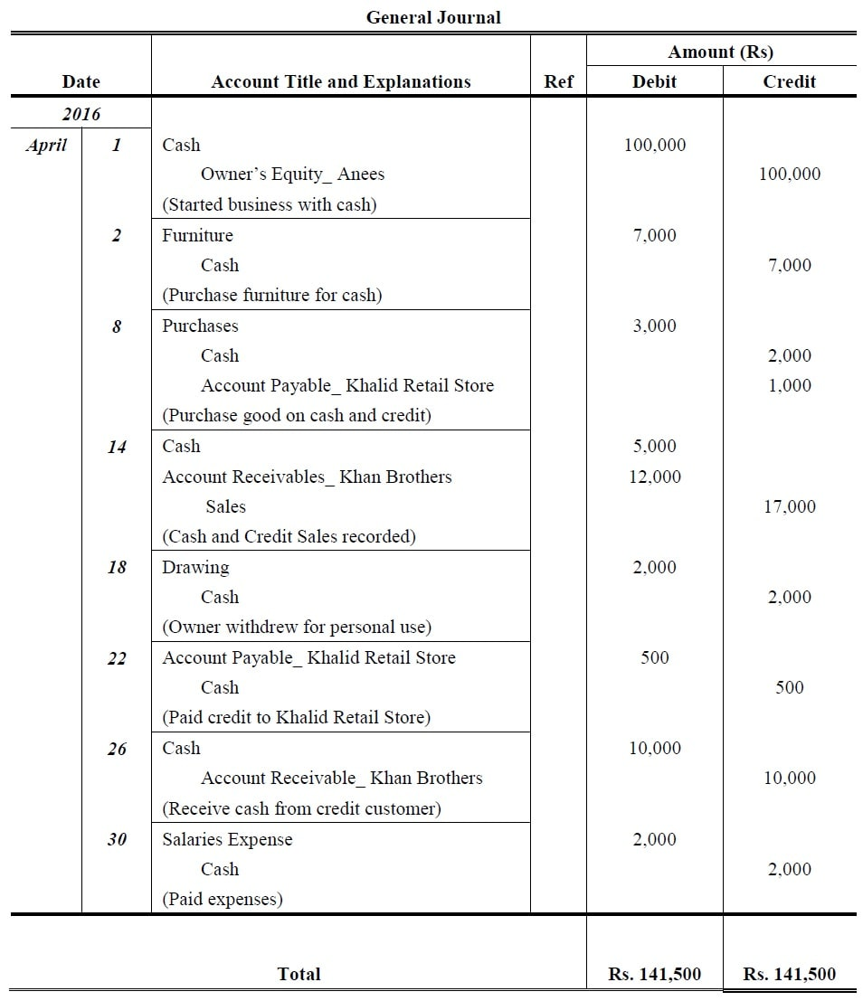

**Problems 2:**

Prepare general journal entries for the following transactions of a business called Pose for Pics in 2016:

***Aug. 1:*** Hashim Khan, the owner, invested Rs. 57,500 cash and Rs. 32,500 of photography equipment in the business.

**04:** Paid Rs. 3,000 cash for an insurance policy covering the next 24 months.

**07:** Services are performed and clients are billed for Rs. 10,000.

**13:** Purchased office supplies for Rs. 1,400. Cash paid Rs. 400 and remaining outstanding.

**20:** Received Rs. 2,000 cash in photography fees earned previously.

**24:** The client immediately pays Rs. 15,000 for services to be performed at a later date.

**29:** The business acquires photography equipment. The purchase price is Rs. 100,000, pays Rs. 25,000 cash and signs a note for the balance.

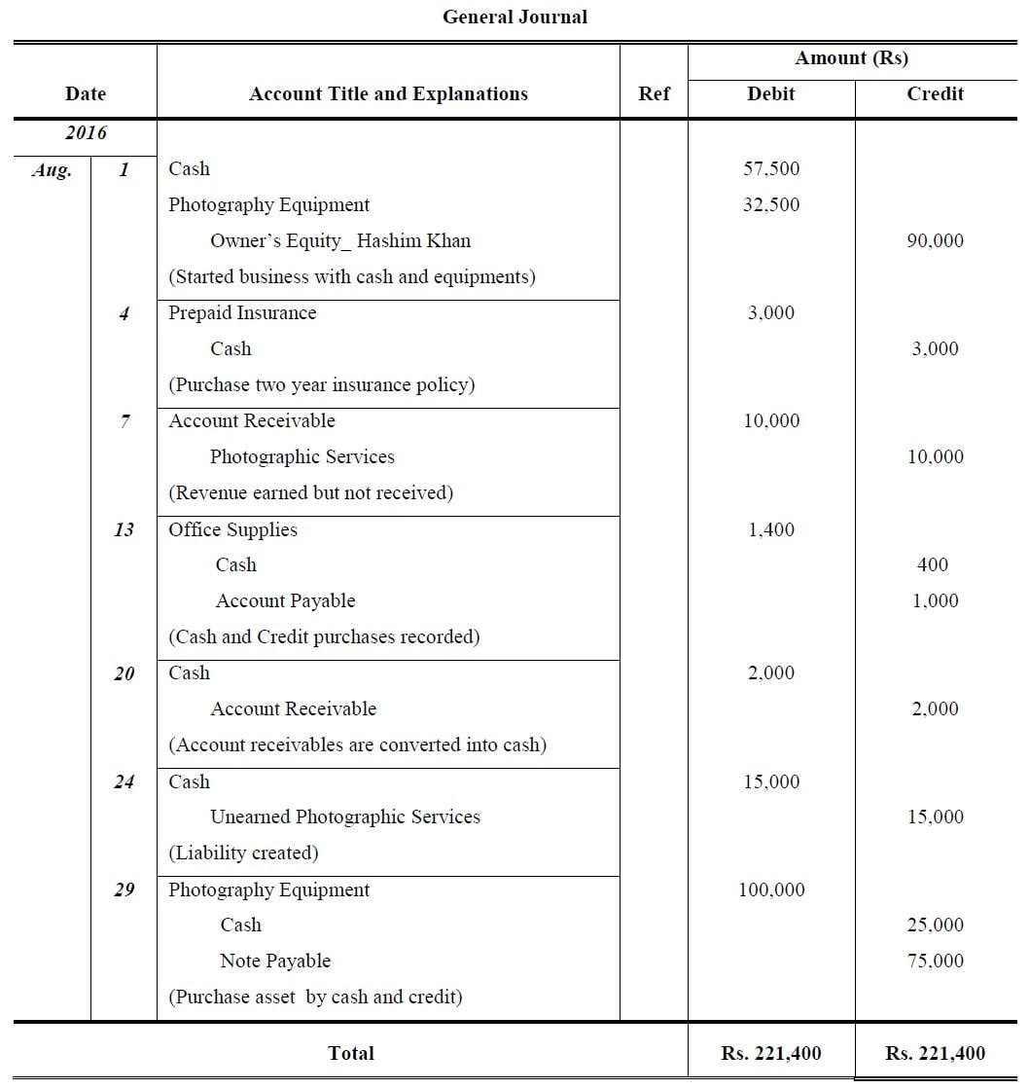

Problem 3:

On March 2017, Farhan Rahim, starts wholesaling business. Following transactions as follows:

1. He started business with capital of Rs. 15,000 and Land worth Rs. 10,000.

8. Bought goods from Bilal and Friends Rs. 1,000 and by cash from XYZ Co. Rs 2,000.

13. Sold goods to Rehman & sons Rs. 1,500 and sale by cash Rs. 5,000.

17. Gave away charity of cash Rs. 50 and merchandising worth Rs. 30.

21. Paid Bilal and Friends cash Rs. 975; discount received Rs. 25.

28. Received cash from Rehman & Sons Rs. 1,450; allowed him discount of Rs. 50.

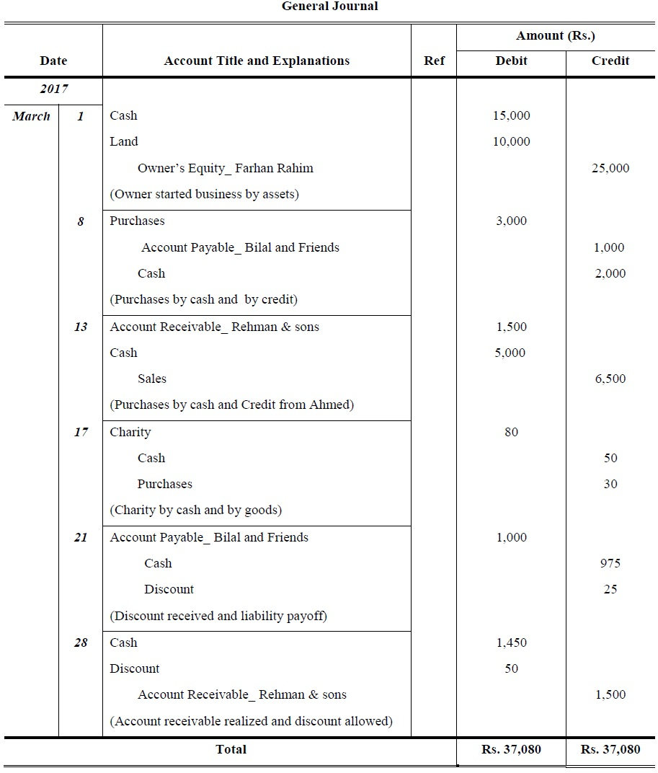

Problem 4:

Shah Sauood Marine is a boat repair yard. During August 2016, its transactions included the following:

03. Loan taken from Habib Bank Ltd. of Rs. 25,000. Rs. 20,000 withdrawn for business and remaining in the bank a/c.

06. Paid rent for the month of August Rs. 4,400 and accrued rent expenses was Rs. 600.

12. At request of Kiwi Insurance, Inc, made repairs on boat of Jon Seaways. Sent bill for Rs. 5,620 for services rendered to Kiwi Insurance Inc. (credit Repair Service Revenue).

18. Made repairs to boat of Dennis Copper and collected in full the charge of Rs. 2,830.

20. Placed Advertisement in The Dawn of Rs. 165, payment to be made within 30 days.

25. Received a check for 5,620 from Kiwi Insurance Inc representing collection of the receivable of August 12.

30. Sent check to The Dawn in payment of the liability incurred on August 20.

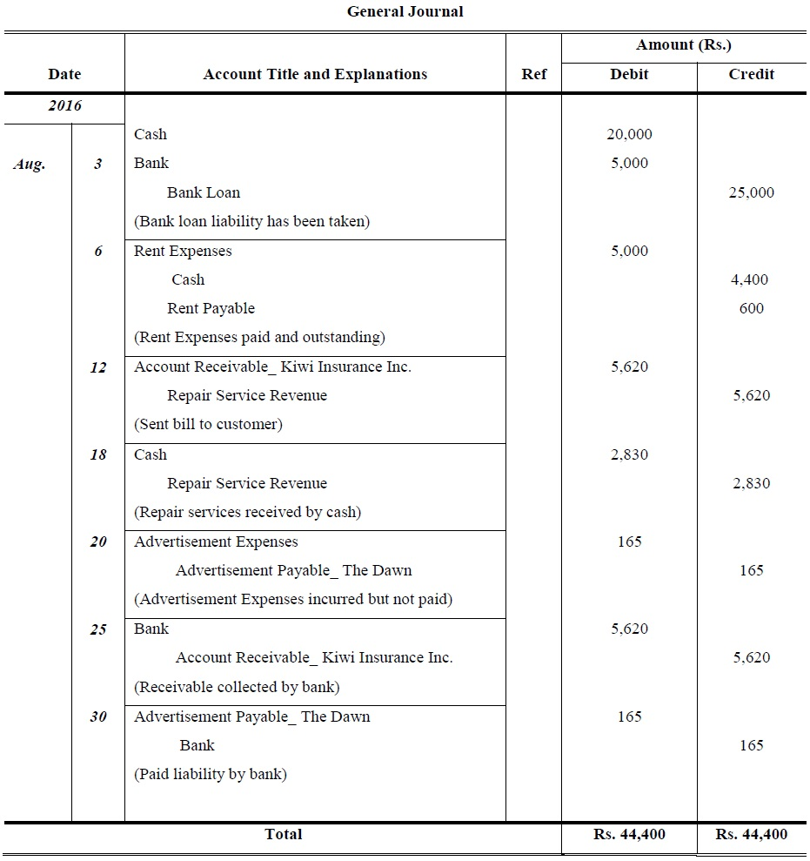

Problems 5:

1st January, 2017, Saeed Ahmad started business other transactions for the month of June as follows:

02. Purchased from Kareem goods of list price of Rs. 6,000 subject to 10% trade discount by cash.

04. Sold goods to Din Muhammad Rs. 800 and cash sales of Rs. 200.

10. Distributed goods worth Rs. 200 as free samples and goods taken away by the proprietor for personal use Rs. 100.

12. Received discount Rs 20 and Commission Rs 500.

17. Goods returned by Din Muhammad Rs. 200 and payment other outstanding amount.

24. Furniture lost by fire of worth Rs. 500.

30. Bad Debts during the period was Rs.100.

